

NCIA – National Cancer Imaging Archive

Software Design Description

Release 2.0 – Parsing Curation Spreadsheet


Document Change Record
Version Number | Date | Description
1.0 | 05/31/06 | Initial document

TABLE OF CONTENTS
1. Introduction 1
1.1 PROJECT BACKGROUND 1
1.2 SYSTEM OVERVIEW 1
1.3 Requirements Traceability 2
1.3.1 Relevant Statement of Work Tasks 2
1.3.2 Functional and Technical Requirements Error! Bookmark not defined.
2. Use Cases 3
2.1.1 New Use Cases 3
2.2 Curation Error! Bookmark not defined.
2.2.1 Curator Enters Data about Images and Annotation Files Use Case 3
2.2.2 Upload Curation Spreadsheet 4
2.2.3 Process Curation Spreadsheet 5
3. System Architecture 9
3.1 curationspreadhseetmdb 9
4. configuration 10
4.1 Deploy curationspreadheetmdb 10
5. Sequence diagrams 11
5.1 upload curation spreadsheet 11
6. Components 13
6.1 USER INTERFACE 13
6.1.1 Spreadsheet Upload Page 13
6.2 User interface Backing Beans 14
6.2.1 SpreadsheetParsingBean 14
6.3 MIDDLE TIER 15
6.3.1 CurationSpreadsheetParser 15
6.3.2 CurationDTO 15
6.3.3 CurationSpreadsheetMessage 16
6.3.4 CurationManager 17
6.4 BACK END 18
6.4.1 Domain Classes 18
6.4.2 Database Design 21
6.5 Enterprise java beans 22
6.5.1 CurationSpreadsheetMDB 22
6.6 Utilities 23
6.6.1 ParsingException 23
6.6.2 CurationError 23

Introduction
The purpose of this document is to describe the design for the Parsing Curation Spreadsheet feature being developed for Release 2.0 of the NCIA – National Cancer Imaging Archive software.
The enhancement will allow a user with sufficient privileges to upload a spreadsheet in pre-defined format to NCIA using the web interface. This spreadsheet will allow for a curator to associate CDEs (Common Data Elements) with an item in NCIA (project, patient, study series, image and annotation file). Also associated with the CDE will be a value for that CDE, the version number and the public ID. Once the upload process has been initiated by the user, it will become an asynchronous task and once completed it will email the user with a report of what (if any) errors occurred during processing.

PROJECT BACKGROUND
Please refer to the NCIA Architecture Overview for background on the NCIA project.

SYSTEM OVERVIEW
Please refer to the NCIA Architecture Overview for a system overview.
.

Requirements Traceability

Relevant Statement of Work Tasks
The NCIA Statement of Work (SOW) Task Description contains the following items that will be implemented as part of this design:
4.8 Provide a Solution for Image and Annotation Curation (2.2.2)
This task involves developing a parsing tool to extract annotations data from a curation spreadsheet into a database. This includes storing parsed annotation data generically (name value pairs) to provide flexibility for various formats.
▪ Assumptions
o Data parsed will not be validated against the caDSR.

Use Cases
User preferences requirements were documented by a combination of adding new use cases and updating existing use cases.

New Use Cases
Use Case Name | Curator Enters Data about Images and Annotation Files
Use Case ID | 5.1
Primary Actor | Curator
Trigger
Pre-conditions
Flow of Events | - Curator reviews an image and wants to add searchable metadata about the image into the database.  - Curator enters the data into a formatted spreadsheet.  - For each piece of data being added, the following is specified in the spreadsheet:  - Association to Images or Annotation File  - Collection name  - Patient ID  - Study Instance UID  - Series Instance UID  - SOP Instance UID  - Annotation File Name  - Common Data Element (CDE) Name to describe the data being entered  - Public ID of the CDE describing the data being entered  - Version of the CDE describing the data being entered  - Value for the data  - Action to take (Delete, or default – Insert)
Post-Conditions | Spreadsheet is ready to be submitted to NCIA. (See use case 5.2)
Alternative Flow | Curator wants to update curation data that already exists in the database. User includes two rows in the spreadsheet: one to delete the existing data and another to insert new data.  CDE does not already exist in caDSR. Curator must add the CDEs to caDSR prior to entering them in the spreadsheet.
Related Use Case
    - Upload Curation Spreadsheet

Use Case Name | Upload and Parse Curation Spreadsheet
Use Case ID | 5.2
Primary Actor | Curator
Trigger
Pre-conditions | - Curator has logged into NCIA (see use case 8.2).  - User has been granted the CURATE privilege in the CSM for at least one protection element representing a collection, site or series security group.
Flow of Events | - Submitter navigates to the “Upload Curation Data” page.  - Curator presses the “Browse” button  - Curator’s browser presents a dialog box that allows selection of a file  - Curator chooses the curation spreadsheet using the dialog box  - Curator presses the “Upload” button  - System receives the file  - Curator is returned to the “Upload Curation Data” page with a message indicating that they will receive an email when the upload and parsing is complete.
Post-Conditions | System processes curation spreadsheet (see use case 5.3)
Alternative Flow | - User has not been granted the CURATE privilege in the CSM for any protection elements representing a collection, site, or series security group. The link to the “Upload Curation Data” page does not appear  - Uploaded file is not an Excel spreadsheet. User is returned the “Upload Curation Data” page with the following message: “The uploaded file is not an Excel spreadsheet”.  - Uploaded file does not contain all header fields or the header fields are not in the correct order. The first row of the spreadsheet must contain the header fields in the correct order. User is returned the “Upload Curation Data” page with the following message: “Column headers are incorrect or in the incorrect order.”
Related Use Case
    - Process Curation Spreadsheet

Use Case Name | Upload and Parse Curation Spreadsheet
Use Case ID | 5.3
Primary Actor | Curator
Trigger
Pre-conditions | A curation spreadsheet has been uploaded
Flow of Events | - For each row in the spreadsheet:  - System determines the collection, patient, study, series, image or annotation file that the data is associated to. This can be specified by providing the following combination of columns of the spreadsheet:  - Collection:  - Data is associated to a collection. System verifies that the collection exists in the database using the collection name and that the user has the CURATE privilege for the collection.  - Collection and Patient ID  - Data is associated to a patient. System verifies that the patient exists in the database using the collection name and patient ID and that the user has the CURATE privilege for the collection and site that the patient belongs to.  - Collection, Patient, and Study Instance UID  - Data is associated to a study. System verifies that the study exists in the database using the collection name, patient ID, and study instance UID and that the user has the CURATE privilege for the collection and site that the patient belongs to.  - Collection, Patient, Study Instance UID and Series Instance UID  - Data is associated to a series. System verifies that the series exists in the database using the collection name, patient ID, study instance UID and series instance UID and that the user has the CURATE privilege for the collection, site and series security group (if any) that the series belongs to.  - Collection, Patient, Study Instance UID and Series Instance UID, SOP Instance UID  - Data is associated to an image. System verifies that the image exists in the database using the collection name, patient ID, study instance UID, series instance UID, and SOP instance UID and that the user has the CURATE privilege for the collection, site and series security group (if any) that the series belongs to.  - Collection, Patient, Study Instance UID and Series Instance UID, Annotation File Name  - Data is associated to an annotation file. System verifies that the image exists in the database using the collection name, patient ID, study instance UID, series instance UID, and annotation file name and that the user has the CURATE privilege for the collection, site and series security group (if any) that the series belongs to.  - System determines the CDE name, ID, version and value based on their respective columns  - System determines the action to be taken based on the Action column (Insert or Delete). If no action is provided, Insert will be used as the default.  - If the action is Delete, system finds the curation data with the same association, CDE name, ID, version and value as the data provided in the spreadsheet. System deletes curation data.  - If the action is Insert, system creates curation data that is associated to the requested collection, patient, study, series, image, or annotation file. The Submitted By and Timestamp fields of the curation data are updated.  - User is sent an email with the results of the upload. The email includes the number of rows processed successfully. For each row where an error occurred, user is provided with the row number along with the error message (see alternative flows).
Post-Conditions
Alternative Flow | - The user does not have the CURATE privilege for the associated data. An error message is included in the email: “User does not have permission to access to the data being curated”.  - Data could not be found in the database that matches the IDs specified for trial, patient, study, series, image, and/or annotation file in the spreadsheet. An error message is included in the email: “Based on the IDs specified, the associated data could not be located”.  - Submitter did not include all required fields (CDE name, ID, version and value) in the spreadsheet. An error message is included in the email: “Required field {0} is missing”, with {0} representing the field name.  - An invalid value was specified in the Action column of the spreadsheet. The only valid values are Insert, Delete, or blank. An error message is included in the email: “An invalid value was specified in the Action column”  - Data being deleted could not be found. An error message is included in the email: “Curation data to be deleted was not found.”  - When inserting new data, the system discovers that curation data already exists with all of the same values. A warning message is included in the email: “Warning: The data to be inserted already exists, so no insert occurred”
Related Use Case

Changes to Existing Use Cases
The changes relevant to this enhancement are highlighted in yellow.

Manage Access to Collection Data

Use Case Name | Manage Access to Collection Data
Use Case ID | 15.2
Primary Actor | Admin User
Trigger | Access needs to be granted or removed for a particular collection’s data.
Pre-conditions | - NCIA has been registered as an application in the CSM User Provisioning Tool (UPT).  - A protection element for the collection has been created.  - Admin User has been granted access to the CSM by the Super Admin User.
Flow of Events | - Admin User logs in to the CSM UPT application for NCIA.  - Admin User goes to the User Home Page.  Admin User clicks Select an Existing User to find the user that is being granted access.  - Admin User grants the user the READ privilege for the protection element representing the collection.  - If the user also needs permission to manage curation data for the collection, the Admin User will grant the user the CURATE privilege for the protection element representing the collection.  - If the user also needs permission to manage the visibility status of the collection, the Admin User will grant the user the MANAGE_VISBILITY_STAUS privilege for the protection element representing the collection.
Post-Conditions | User is able to view data for the collection.
Alternative Flow | - User needs to have access to a collection removed. Admin User finds the user in UPT then removes the READ privilege for the collection’s protection element.  - A decision has been made to grant all users the ability to view a collection’s data. The protection element is placed in the public group, making it accessible to all users.
Related Use Case

System Architecture

curationspreadsheetmdb
A new message driven bean (MDB) will be added to the system so that the insertion of the curation data provided in the spreadsheet will be an asynchronous task. This MDB will become part of the ncia.ear file and be deployed with the NCIA application. See Section 6.5.

configuration

Deploy curationspreadheetmdb
For this enhancement, we will be creating another Message Driven Bean (MDB) so that the insertion of the curation data found in the spreadsheet will be an asynchronous task that will be able to email the user with report of the errors once completed. In order to configure this MDB, the EJB deployment descriptor will have to be modified. In NCIA, the two relevant files are ejb-jar.xml and jboss.xml. A MessageSelector will be used in order to be able to use the same JMS Queue for both the CurationMessages and the ImageZippingMessagesAlso to support the CurationSpreadsheetMDB.

JMS Queue

Currently, there is a JMS Queue being used by NCIA for the ImageZippingMDB. Its current name is imageQueue. Since we will be placing both ImageZippingMessages and CurationMessages on this queue now, it will be renamed to nciaQueue. In order to do this ncia-jbossmq-destinations-service.xml will be modified.

mail.properties
Changes will be made to mail.properties in order to include text for the email that will be sent to the user that uploads the spreadsheet.

Sequence diagrams
For some use cases, sequence diagrams are helpful to illustrate the execution flow. Sequence diagrams are included this section for the appropriate use cases. Details of the objects that participate in the use cases are described in section 6.

upload curation spreadsheet
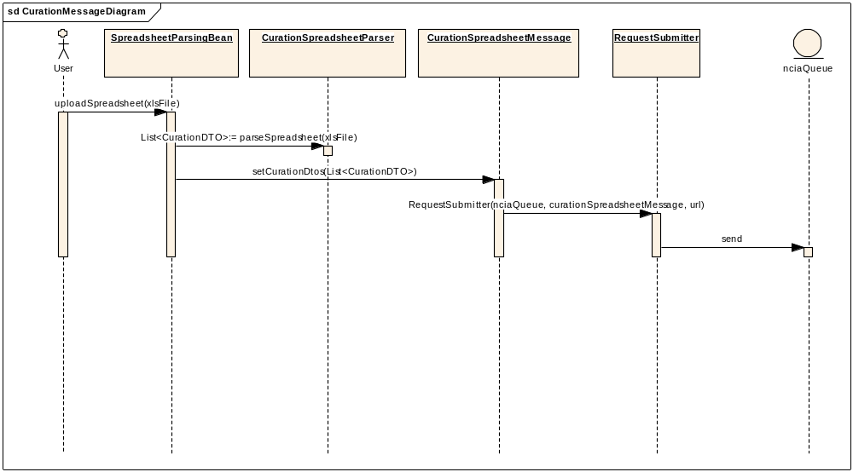

Process Curation Spreadsheet
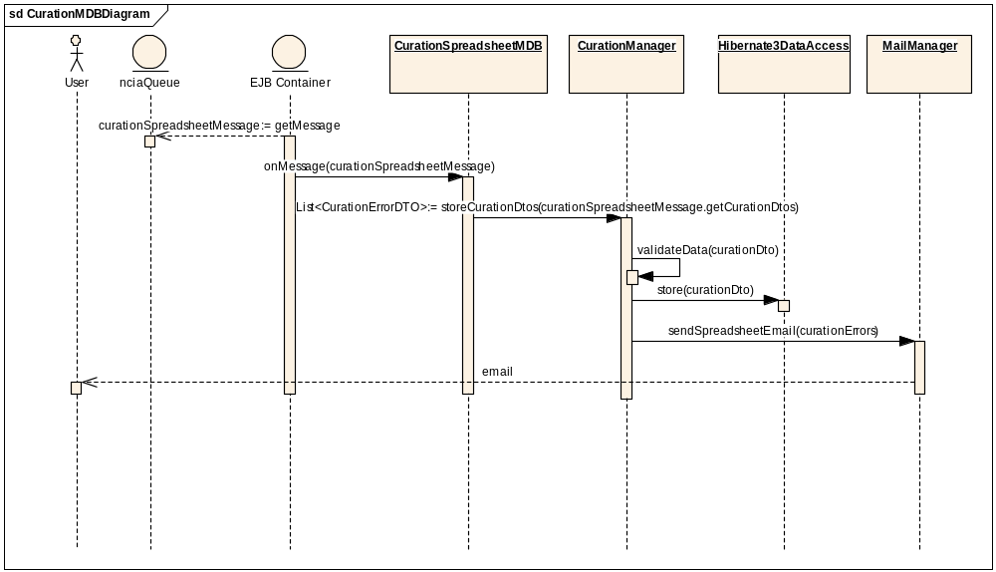

Components

USER INTERFACE

Spreadsheet Upload Page
There will be a new link on the left hand navigation bar that will appear for users that have the CURATE privilege for at least one protection element.
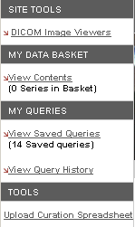

On the page, there will be a file upload dialog that will start the spreadsheet parsing process. It will use the inputFileUpload component from the Apache Tomahawk project (http://myfaces.apache.org/tomahawk/index.html).
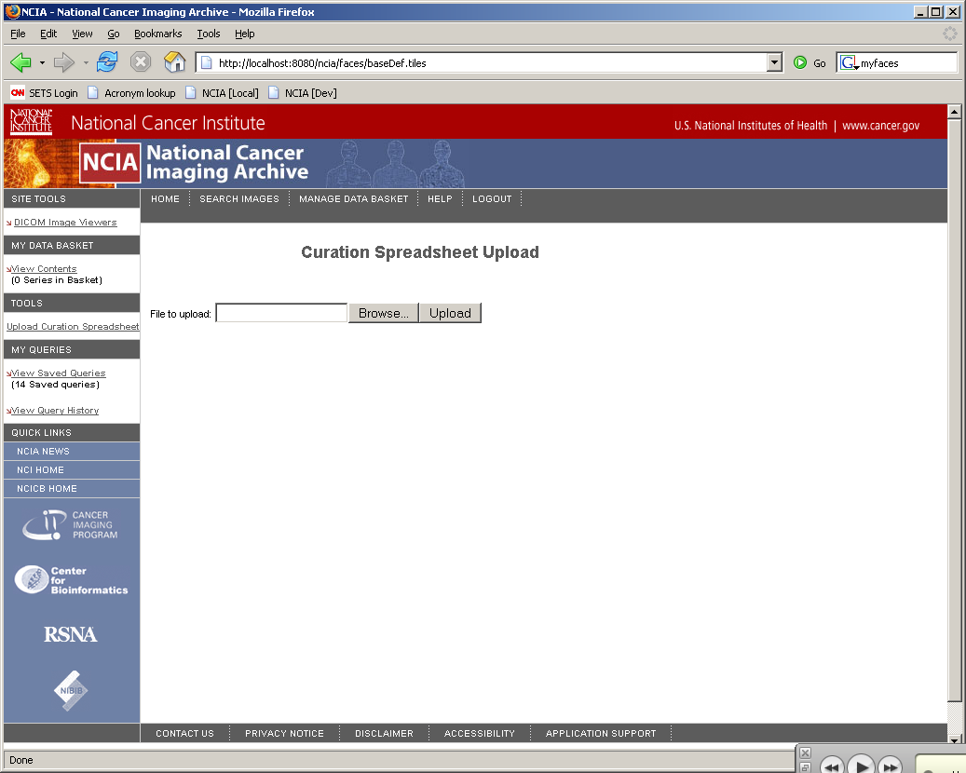

User interface Backing Beans

SpreadsheetParsingBean
SpredsheetParsingBean is the backing bean for the spreadsheet upload page. When a user uploads a file, the CurationSpreadheetParser will be called for that file. This will do some very basic validation of fatal errors. If there are any fatal errors, they will be displayed on the user interface. Otherwise, a List of CurationDTOs will be returned from the CurationSpreadsheetParser. These CurationDTOs will be put in the CurationMessage and then put onto the queue.
New Method Name | Description
uploadFile | This method is performed when the file is uploaded. It will call the CurationSpreadsheetParser and CurationMessage. It will check if a CurationParsingException is thrown from the CurationSpreadsheetParser, if one is, it will display the message on the UI. Otherwise, it will create a CurationMessage and place it on the queue.

New Attribute Name | Attribute Type | Description
fileName | String | Holds the name of the file that is being uploaded.

MIDDLE TIER

CurationSpreadsheetParser
This class will handle the parsing of the curation spreadsheet. It will take the Excel spreadsheet file as input. It will check for fatal errors such as invalid file format. If the file is invalid, it will return to the backing bean to display error messages. While parsing, it will create a List of CurationDTOs. It will use Jakarta POI API to parse the spreadsheet. No data validation against the database will occur during parsing, all will be done on the back end by the MDB.

New Method Name | Description
parseSpreadsheet | This method will take in the file and do the actual parsing of the spreadsheet. It will throw a CurationParsingException if there is a problem parsing the spreadsheet. If the file uploaded is not a valid spreadsheet, the following message will be displayed on the UI: “The uploaded file is not an Excel spreadsheet”. If the spreadsheet does not contain the correct column headers in the correct order, as defined by the constants in the class CurationConstants, the UI will display the following message: “Column headers are incorrect or in the incorrect order”. Otherwise, it will put all relevant data into the CurationDTOs and return the list of created DTOs when finished.

CurationDTO
The CurationDTO will be the object that contains information for each row in the spreadsheet. It will have all information necessary to store a CurationData object into the database once the DTOs have been put on the CurationSpreadsheetMessage and processed by the CurationSpreadsheetMDB.
New Attribute Name | Attribute Type | Description
project | String | Holds the project
patientUid | String | Holds the Patient ID
studyInstanceUid | String | Holds the Study ID
seriesInstanceUid | String | Holds the Series ID
sopInstanceUid | String | Holds the Image ID
annotationFileName | String | Name of the annotation file to add a CDE to
cdeName | String | Name of the CDE
cdePublicId | int | Public ID of the CDE
cdePublicVersion | String | Version of the CDE being used
cdeValue | String | Value of the CDE
action | Enum | Desired action for the CurationManager to perform (insert, delete)
rowNumber | int | The original row number of the current record

CurationMessage
The CurationMessage will be the actual message that is stored on the queue. It will contain all of the CurationDTOs that should be stored from this spreadsheet. It will also contain the email address of the user that submitted the file so they can be informed of the completion of parsing and also receive error reports. Before this message is placed on the queue, the setStringProperty(“messageType”, “curation”) must be invoked so that the MessageSelector will work.
New Attribute Name | Attribute Type | Description
CurationDtos | List<CurationDTO> | Holds all of the CurationDTOs that should be stored from this spreadsheet.
SpreadsheetFileName | String | The filename of the original spreadsheet
EmailAddress | String | Email address of the user who submitted the file

CurationManager

The CurationManager is the class that will be responsible for performing the validation of the CurationDTOs before they are actually stored into the database. It will make sure that all of the Ids are correct and then store the domain class with the proper relationships. It will return a list of errors back to the MDB that called it in the form of a CurationError.
New Method Name | Description
storeCurationDtos | This is the method that will be called by the MDB. It will take the list of CurationDTOs to store. First, it will make sure that the DTO is valid before it is stored using the validateData method. It will then take the CurationDTO and map the values in the DTO to the CurationData domain class by hooking up all necessary relationships. Then it will perform the action that is specified by the spreadsheet (insert or delete) using Hibernate3DataAccess to persist the CurationData item. This method will return a list of CurationErrors that arise from validating the data.
validateData | This method will validate the data stored in the CurationDTO against the database. It will validate the following things:  - It will ensure that the project, patient id, study id, series id and image id are all valid. If they are not, it will create a CurationError with the following message: “Based on the IDs specified, the associated data could not be located”.  - It will also check for duplicates by seeing if a CurationData object already exists with all of the same information that is on the DTO (project, patient id, study id, series id, image id, CDE name, CDE id, CDE version and value). If it already exists, then a warning CurationError object will be created with the message ”Warning: The data to be inserted already exists, so no insert occurred”. If not, a new CurationData object will be created.  - This process will also verify that the user who submitted the spreadsheet has the CURATE privilege for the collection and site that the patient belongs to. The priveleges are based upon the following rules:  - Collection:  - Data is associated to a collection. System verifies that the collection exists in the database using the collection name and that the user has the CURATE privilege for the collection.  - Collection and Patient ID  - Data is associated to a patient. System verifies that the patient exists in the database using the collection name and patient ID and that the user has the CURATE privilege for the collection and site that the patient belongs to.  - Collection, Patient, and Study Instance UID  - Data is associated to a study. System verifies that the study exists in the database using the collection name, patient ID, and study instance UID and that the user has the CURATE privilege for the collection and site that the patient belongs to.  - Collection, Patient, Study Instance UID and Series Instance UID  - Data is associated to a series. System verifies that the series exists in the database using the collection name, patient ID, study instance UID and series instance UID and that the user has the CURATE privilege for the collection, site and series security group (if any) that the series belongs to.  - Collection, Patient, Study Instance UID and Series Instance UID, SOP Instance UID  - Data is associated to an image. System verifies that the image exists in the database using the collection name, patient ID, study instance UID, series instance UID, and SOP instance UID and that the user has the CURATE privilege for the collection, site and series security group (if any) that the series belongs to.  - Collection, Patient, Study Instance UID and Series Instance UID, Annotation File Name  - Data is associated to an annotation file. System verifies that the image exists in the database using the collection name, patient ID, study instance UID, series instance UID, and annotation file name and that the user has the CURATE privilege for the collection, site and series security group (if any) that the series belongs to.  If they do not have the correct privilege, it will create a CurationError with the following message: “User does not have permission to access to the data being curated”.  - If the submitter did not include all of the required fields, it will create a CurationError with this message: “Required field {0} is missing”, with {0} representing the field name.  - If An invalid value was specified in the Action column of the spreadsheet. The only valid values are Insert, Delete, or blank. An error message is included in the email: “An invalid value was specified in the Action column”  - Data being deleted could not be found. An error message is included in the email: “Curation data to be deleted was not found.”

BACK END

Domain Classes
There are two types of domain classes that are going to be created for this enhancement. There are the traditional domain classes that are going to be modeled using the caCORE SDK, and then there are the domain objects that are going to be represented in the updateabledomain package that is maintained by NCIA. The updateabledomain package was created during Release 1.2 prior to the availability of the writable caCORE SDK API to persist saved queries, query history, and reporting data. Since NCIA needs to persist parent and child objects in the same transaction, the current functionality of the writeable caCORE SDK API cannot be used.

CurationData
Description: This will represent a CDE that is associated to a specific object (trial, patient, study, series, image, file annotation). The lowest level of association will be the actual object that the CDE and its value are associated with. E.g. an image CurationData object will have an association to series, study, patient and trial as well. This class will be present in both the domain package as well as the updateabledomain package so that Hibernate3DataAccess can insert and delete the object.
Attributes:
Attribute Name | Attribute Type | Description
Id | Integer | The Id of the CurationData object. Correlates to the PK ID in the database.
TrialDataProvenance | TrialDataProvenance | This is the item that will hold the Trial UID and the Trial PK ID
Patient | Patient | This will hold the Patient UID and the Patient PK ID
Study | Study | This will hold the Study UID and Study PK ID
GeneralSeries | GeneralSeries | This will hold the Series UID and Series PK ID
GeneralImage | GeneralImage | This will hold the Image UID and Image PK ID
AnnotationFile | Annotation | This will hold the Annotation File Path and the Annotation PK ID
CdeName | String | The name of the CDE from caDSR.
CdeValue | String | The value that the current CDE has for this data object.
CdeId | String | The ID of the CDE from caDSR.
CdeVersion | String | The version of the CDE from caDSR
User | NCIAUser | The user that this CurationData object was inserted by. Should have CURATE privileges for the patient and trial.
CurationTimestamp | Date | The most recent date that the CurationData object has been updated

TrialDataProvenance

Description: This will be a lightweight TrialDataProvenance object that exists in the updateabledomain package so that Hibernate3DataAccess will be able to create the association between the TrialDataProvenance and CurationData.
New Attribute Name | Attribute Type | Description
Id | Integer | The PKID of the project
DpSiteName | String | The name of the project

Patient

Description: This will be a lightweight Patient object that exists in the updateabledomain package so that Hibernate3DataAccess will be able to create the association between the Patient and CurationData.
New Attribute Name | Attribute Type | Description
Id | Integer | The PKID of the patient
PatientId | String | The UID of the patient

Study

Description: This will be a lightweight Study object that exists in the updateabledomain package so that Hibernate3DataAccess will be able to create the association between the Study and CurationData.
New Attribute Name | Attribute Type | Description
Id | Integer | The PKID of the study
StudyInstanceUID | String | The UID of the study

GeneralSeries

Description: This will be a lightweight GeneralSeries object that exists in the updateabledomain package so that Hibernate3DataAccess will be able to create the association between the GeneralSeries and CurationData.
New Attribute Name | Attribute Type | Description
Id | Integer | The PKID of the series
SeriesInstanceUID | String | The UID of the series

GeneralImage

Description: This will be a lightweight GeneralImage object that exists in the updateabledomain package so that Hibernate3DataAccess will be able to create the association between the GeneralImage and CurationData.
New Attribute Name | Attribute Type | Description
Id | Integer | The PKID of the GeneralImage
SOPInstanceUID | String | The UID of the image

Annotation

Description: This will be a lightweight Annotation object that exists in the updateabledomain package so that Hibernate3DataAccess will be able to create the association between the Annotation and CurationData.
New Attribute Name | Attribute Type | Description
Id | Integer | The PKID of the annotation
FilePath | String | The path of the annotation file

Hibernate Mapping Files

Here is a list of the Hibernate mapping files that will be created for this enhancement:

CurationData.hbm.xml

TrialDataProvenance.hbm.xml

Patient.hbm.xml

Study.hbm.xml

GeneralSeries.hbm.xml

GeneralImage.hbm.xml

Annotation.hbm.xml

Database Design

CURATION_DATA
Table: CURATION_DATA
Column Name | Column Type | Class / Attribute Name
CURATION_DATA_PK_ID | NUMBER | CurationData.Id
TRIAL_DP_PK_ID | NUMBER | CurationData.TrialDataProvenance
PATIENT_PK_ID | NUMBER | CurationData.Patient
STUDY_PK_ID | NUMBER | CurationData.Study
GENERAL_SERIES_PK_ID | NUMBER | CurationData.GeneralSeries
IMAGE_PK_ID | NUMBER | CurationData.GeneralImage
ANNOTATIONS_PK_ID | NUMBER | CurationData.Annotation
CDE_NAME | VARCHAR2(100) | CurationData.CdeName
CDE_VALUE | VARCHAR2(4000) | CurationData.CdeValue
CDE_PUBLIC_ID | VARCHAR2(50) | CurationData.CdeId
CDE_PUBLIC_ID_VERSION | VARCHAR2(50) | CurationData.CdeVersion
USER_ID | NUMBER | CurationData.User
CURATION_TIMESTAMP | DATE | CurationData.CurationTimestamp

Enterprise java beans

CurationSpreadsheetMDB

The CurationSpreadhseetMDB will be the class responsible for the asynchronous processing of the spreadsheet. It will call the CurationManager in order to validate the CurationDTOs stored on the CurationMessage. Once all of the DTOs have been processed, the MDB will get back a list of errors from the CurationManger, formulate an email to send to the submitter and send it using MailManager.
New Method Name | Description
onMessage | When this MDB receives a CurationMessage, it will take the CurationDTOs off of the message. Then, it will use the CurationManager to validate and store all of the CurationDTOs that were on the message. The CurationManager will return a list of CurationErrors from the storeCurationDtos method. These messages will be put into an email and sent to the submitter of the spreadsheet with the spreadsheet name, number of rows processed and a list of all warnings and errors. In the case that the MDB fails for any reason, the CurationMessage will be put back on the queue. Once another MDB picks up the message and completes the process, the user will receive the email, only this time it could possibly contain warnings because the message was partially processed when the MDB failed the first time.

ImageZippingMessage

Before this message is placed on the queue, the setStringProperty(“messageType”, “image”) must be invoked so that the MessageSelector will work.

Utilities

CurationParsingException

This exception will be thrown from the CurationSpreadsheetParser. It will contain the message of why the spreadsheet cannot be parsed. Reasons for this exception are that the file is not a valid spreadsheet or the spreadsheet does not contain the correct column headings in the correct order.

CurationError

A CurationError is the object that gets returned from the CurationManager. It will have different levels (warning and error) as well as a row number that the error is associated with, and the actual error message. These errors will then be put into the email.
New Attribute Name | Attribute Type | Description
Level | Enum | The severity of the error, warning or error
Message | String | The full text of the error message
Row | Integer | The row number that the error occurred on

MailManager

A method to send the curator the results of their uploaded spreadsheet must be added to the MailManger.
New Method Name | Description
sendSpreadsheetEmail | This will send an email to the user who submitted the spreadsheet with the following text:  “Thank you for submitting spreadsheet [spreadsheet name] to NCIA. [number of rows] were inserted correctly.  There were [number of errors] while inserting the data. Please correct the following errors and resubmit this data:  [List of errors]  There were [number of warnings] while inserting the data:  [List of warnings]”

